The following steps outline the procedure to download our solitaire game as a standalone runnable .exe file.

When viewing the master branch of the CTS8334-Solitaire repository, this is the page you should see:

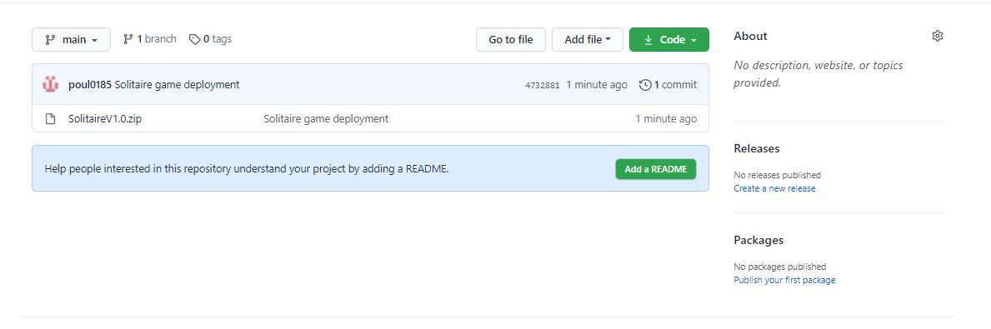

From here, click on the file named SolitaireV1.0.zip. The following page should appear:

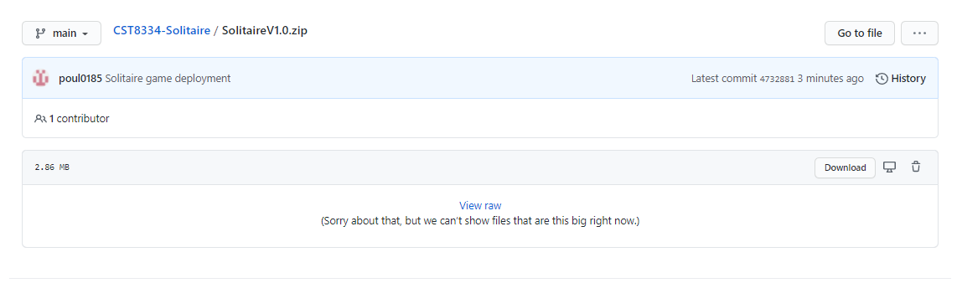

Next, click on the “Download” button as highlighted below:

Next, navigate to your “Downloads” folder in your file explorer to find the following zip folder:

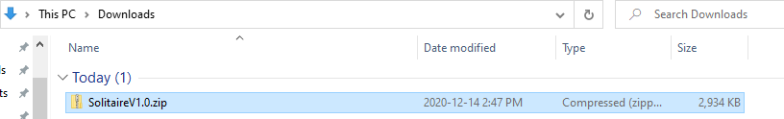

From here, you may choose to move this folder to any directory of your choice.

Once the folder is in its home directory, you must extract/unzip the folder using your preferred means:

In this case, the following steps were taken to extract the zip folder:

1. Right-click the SolitaireV1.0.zip folder
2. Navigate to the 7-zip tab in the menu
3. Click ‘Extract to “SolitaireV1.0\” ‘ in the submenu

This should create a new file of the same name which is no longer a zip folder:

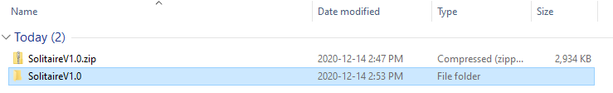

Now, navigating into this new folder you should find a .exe file type called “Solitair”. Running this file will launch the solitaire game:

